Alexander King
CSET 4250 – Homework #1

1) Explain the difference between hardware and software.
If you can hit it with a hammer it is hardware (physical). Software can only be cursed at (not physical).
Hardware is used to run software. Software is a program.
Examples-
Hardware: motherboard, cpu, gpu, hdd, RAM, etc…
Software: Windows, LibreOffice, MalwareBytes, Chrome, Starcraft II, etc...
2) What are the 4 types of computer software discussed in class?
Application, operating system, firmware, drivers.

3) What is Computer programming?
The process of creating programs in the same way painting is the process of creating art. The goal is to accomplish some task the programmer has imagined.

4) Explain the programming process.
Start with a goal. Consider ways to accomplish the goal as well as the advantages and disadvantages of the methods you have imagined. Write psudocode. Write code. Test the code. Deploy the code. Document the code.

5) Explain Structured programming – in your own words.

Structured programming is modular programming. Having sub-programs that can be more easily changed and or reused. Structured programming will use commands like if while and for instead of commands like do. We do this because it allows the code to be more easily used elsewhere or discarded. It also helps us work in teams more easily because we can all work on our own sections independently. This is advantageous in my opinion because coders wont have interference or unknown mystery edits happening in their assigned portion of the work. One entry point and one exit.

6) Arguments for and against having a single language for all programming domains are:
For: A conformity for compatibility and fewer barriers to be able to learn it the skill.
Against: Different languages function differently. Some languages are better suited to some tasks vs others. The cost to develop something in a language that isn’t suited for the task isn’t efficient.

7) Explain the Von Neumann model. What is the Von Neumann bottleneck?
The Von-Neumann architecture: A user gives an input that is run through a program and processed by the CPU/RAM and then provides an output. The von-neumann bottle neck is the speed of the bus is slower than the memory or CPU speed.
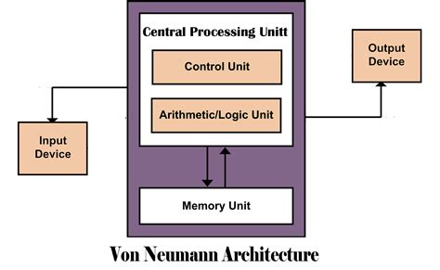Figure 1: Georgetown University - < https://blogs.commons.georgetown.edu/cctp-820-fall2016/category/week-7/ >

